
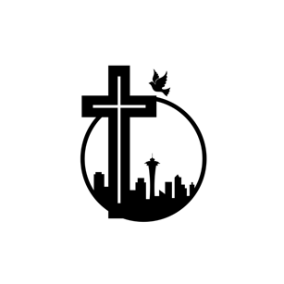

西雅圖靈糧堂
Bread of Life Christian Church in Seattle

受 洗 證 書
Baptism Certificate
茲證明 陳小明 弟兄/姊妹
已接受耶穌基督為個人的救主與生命的主宰，清楚得救的意義，於主後2023年 1月1日，
奉聖父、聖子、聖靈的名予以施浸，歸入基督名下，謹此證明。
This certifies that brother/Sister Xiao Ming Chen has solemnly accepted Jesus Christ as his/her personal Lord and Savior, understands the meaning of baptism and was baptized on 1 / 1 / 2023, in the name of the Father, of the Son and of the Holy Spirit.

___________________ 周吉仁牧師 Pastor Chow

